Java Collections Framework and Hierarchy
The Java Collections Framework (JCF) is a unified class library for storing and manipulating data. Its core interfaces split into two branches: Collection (with List, Set, Queue) and the standalone Map (key-value pairs). Common implementations include ArrayList, HashSet, TreeMap, along with the Collections utility. It provides efficient algorithms and good extensibility, forming a fundamental part of Java development.

How ArrayList Implements Dynamic Resizing
The variable-length behavior of ArrayList is implemented through an internal Object[] array—it does not truly resize, but dynamically expands when capacity is exhausted. On the first add, the default capacity becomes 10; subsequently, if the current array is too small, it expands to roughly 1.5 times the old capacity (oldCapacity + (oldCapacity >> 1)), or directly to the required minimum if that is still insufficient. Expansion creates a new, larger array and copies all elements using System.arraycopy(), while the old array becomes eligible for garbage collection. Since expansion involves array creation and element copying, it is costly; thus, if you can estimate the data size in advance, specifying an initial capacity via the constructor is recommended to avoid repeated performance penalties.

Generics
In Java, generics (introduced in JDK 1.5) are a core feature that essentially provides “parameterised types”. As one of the most frequently used collection classes, ArrayList integrates generics throughout its declaration, instantiation, internal implementation, and usage. Below we dive into the mechanisms and practical applications.
public class ArrayList<E> extends AbstractList<E> implements List<E> { ... }
Generics in ArrayList provide compile-time type safety while relying on type erasure at runtime, meaning all generic parameters are removed after compilation and the internal storage remains an Object[]. The diamond operator (<>) lets you omit the type on instantiation, but using a raw type disables compile-time checks and forces manual casting, which can lead to ClassCastException. The compiler verifies that only compatible elements are added and automatically inserts casts when you retrieve values, so no explicit downcasting is needed in your code. At runtime, ArrayList<String> and ArrayList<Integer> are the same class, and you cannot use instanceof to test generic types. For method parameters, wildcards add flexibility: <? extends T> allows reading elements (a producer), while <? super T> allows writing elements (a consumer), following the PECS rule. You can also declare generic methods that are independent of the class-level type parameter. However, there are important limitations: primitive types must be wrapped (e.g., use Integer instead of int), you cannot instantiate a type parameter or create arrays of generic types, and static members cannot reference the class-level generic E. Despite these constraints, generics greatly improve code clarity, eliminate unsafe casts, and catch type errors early, making them indispensable for robust collection handling in Java.

ArrayList Methods Showcase & Practical Demo
package ArrayLists;
import java.util.*;
/**
* ArrayList core API demonstration with assertions.
* Run with JVM assertion enabled: -ea
*/
public final class ArrayListDemonstration {
// ===== Test Data =====
private static final List<String> BASE = List.of("Frozen", "Zootopia", "Moana");
private static final List<String> EXTRA = List.of("Coco", "Inside Out");
private static final List<String> DUPLICATE = List.of("Frozen", "Zootopia", "Moana", "Zootopia");
private ArrayListDemonstration() {
throw new UnsupportedOperationException("Utility class – instantiation prohibited");
}
public static void main(String[] args) {
log("INFO", "Starting ArrayList comprehensive demonstration...");
demonstrateConstructor();
demonstrateAddition();
demonstrateQuery();
demonstrateModifyAndDelete();
demonstrateTraversal();
demonstrateSorting();
demonstrateConversionAndSublist();
demonstrateCapacity();
demonstrateReplaceAndClone();
demonstrateSynchronizedWrapper();
log("INFO", "All demonstrations passed.");
}
/** Constructors: default, capacity-specified, and copy */
private static void demonstrateConstructor() {
log("SECTION", "Constructors");
ArrayList<String> defaultList = new ArrayList<>();
assert defaultList.isEmpty();
ArrayList<String> capacityList = new ArrayList<>(20);
assert capacityList.size() == 0;
ArrayList<String> copiedList = new ArrayList<>(BASE);
assert copiedList.size() == BASE.size();
log("PASS", "Constructor validation passed.");
}
/** Addition: single element, indexed insertion, batch append, offset batch */
private static void demonstrateAddition() {
log("SECTION", "Addition Operations");
ArrayList<String> list = new ArrayList<>(BASE);
list.add(1, "Toy Story");
assert list.get(1).equals("Toy Story");
list.addAll(EXTRA);
assert list.containsAll(EXTRA);
list.addAll(2, List.of("Brave", "Tangled"));
assert list.get(2).equals("Brave");
log("PASS", "Addition operations passed. Current size: " + list.size());
}
/** Query: get, contains, indexOf, lastIndexOf, isEmpty, size */
private static void demonstrateQuery() {
log("SECTION", "Query Operations");
ArrayList<String> list = new ArrayList<>(DUPLICATE);
assert list.get(2).equals("Moana");
assert list.indexOf("Zootopia") == 1;
assert list.lastIndexOf("Zootopia") == 3;
assert list.contains("Frozen");
assert !list.isEmpty();
log("PASS", "Query operations passed. Size: " + list.size());
}
/** Modification & Deletion: set, remove(index), remove(object), removeIf, retainAll */
private static void demonstrateModifyAndDelete() {
log("SECTION", "Modification & Deletion");
ArrayList<String> list = new ArrayList<>(List.of(
"Frozen", "Toy Story", "Zootopia", "Moana", "Coco", "Tangled"
));
String replaced = list.set(0, "Frozen 2");
assert replaced.equals("Frozen");
assert list.get(0).equals("Frozen 2");
String removedByIndex = list.remove(2);
assert removedByIndex.equals("Zootopia");
boolean removedByObj = list.remove("Coco");
assert removedByObj;
boolean removedIf = list.removeIf(s -> s.startsWith("T"));
assert removedIf;
boolean retained = list.retainAll(List.of("Frozen 2", "Moana"));
assert retained;
assert list.size() == 2;
log("PASS", "Modification & deletion passed.");
}
/** Traversal: for, enhanced for, Iterator, ListIterator, forEach, Stream */
private static void demonstrateTraversal() {
log("SECTION", "Traversal Strategies");
ArrayList<String> list = new ArrayList<>(List.of("A", "B", "C"));
int count = 0;
Iterator<String> it = list.iterator();
while (it.hasNext()) { it.next(); count++; }
assert count == list.size();
ListIterator<String> lit = list.listIterator();
while (lit.hasNext()) { lit.next(); }
list.forEach(Objects::requireNonNull);
long streamCount = list.stream().map(String::toUpperCase).count();
assert streamCount == list.size();
log("PASS", "All traversal mechanisms executed normally.");
}
/** Sorting: natural order, by length, reverse order */
private static void demonstrateSorting() {
log("SECTION", "Sorting Mechanisms");
ArrayList<String> list = new ArrayList<>(List.of("Frozen", "Zootopia", "Moana", "Brave"));
list.sort(Comparator.naturalOrder());
assert list.get(0).equals("Brave");
list.sort(Comparator.comparingInt(String::length));
assert list.get(0).length() <= list.get(1).length();
list.sort(Comparator.reverseOrder());
assert list.get(0).compareTo(list.get(1)) >= 0;
log("PASS", "Sorting validation passed.");
}
/** Conversion & Sublist: toArray, subList (view – modifications affect the original) */
private static void demonstrateConversionAndSublist() {
log("SECTION", "Conversion & Sublist");
ArrayList<String> list = new ArrayList<>(List.of("A", "B", "C", "D", "E"));
String[] arr = list.toArray(new String[0]);
assert arr.length == list.size();
List<String> sub = list.subList(1, 4); // [B, C, D]
assert sub.size() == 3;
sub.set(0, "X");
assert list.get(1).equals("X");
log("PASS", "Conversion & sublist passed (sublist is a backed view).");
}
/** Capacity management: ensureCapacity (pre-allocation), trimToSize (shrink) */
private static void demonstrateCapacity() {
log("SECTION", "Capacity Management");
ArrayList<String> list = new ArrayList<>(2);
list.add("A");
list.add("B");
list.add("C");
list.ensureCapacity(50); // pre-expand
list.trimToSize(); // shrink to actual size
assert list.size() == 3;
log("PASS", "Capacity management executed.");
}
/** Bulk replace & Clone: replaceAll, clone (shallow copy) */
private static void demonstrateReplaceAndClone() {
log("SECTION", "Bulk Replace & Clone");
ArrayList<String> list = new ArrayList<>(List.of("A", "B", "C"));
list.replaceAll(s -> s + "!");
assert list.get(0).equals("A!");
@SuppressWarnings("unchecked")
ArrayList<String> cloned = (ArrayList<String>) list.clone();
cloned.set(0, "Modified");
assert !list.get(0).equals(cloned.get(0));
log("PASS", "replaceAll and clone (shallow copy) passed.");
}
/** Synchronized wrapper: Collections.synchronizedList (iteration needs external sync) */
private static void demonstrateSynchronizedWrapper() {
log("SECTION", "Synchronized Wrapper");
ArrayList<String> list = new ArrayList<>(List.of("Sync", "Safe"));
List<String> syncList = Collections.synchronizedList(list);
synchronized (syncList) {
Iterator<String> it = syncList.iterator();
while (it.hasNext()) { it.next(); }
}
log("PASS", "Synchronized wrapper created and iterated safely.");
}
// ===== Unified logging =====
private static void log(String level, String msg) {
if ("SECTION".equals(level)) {
System.out.printf("%n[TEST] %s%n", msg);
} else if ("ERROR".equals(level)) {
System.err.println("[ERROR] ❌ " + msg);
} else {
System.out.println("[" + level + "] " + msg);
}
}
}

ArrayList and LinkedList
Variable-Length Principle & Automatic Resizing Mechanism: ArrayList vs. LinkedList
Both ArrayList and LinkedList are implementations of the List interface in Java that support dynamic sizing—meaning they can grow or shrink as elements are added or removed. However, the underlying data structures and resizing strategies are fundamentally different.
ArrayList – Dynamic Array with Bounded Capacity
- Underlying Structure: ArrayList is backed by a contiguous array in memory. When you create an ArrayList with the default constructor, it initialises an internal array with a default capacity (typically 10). This capacity is not the size (number of elements); it is the pre-allocated space.
- Automatic Expansion (Resizing):
When you add an element and the current size equals the capacity, the ArrayList must expand to accommodate the new element. The resizing policy (in most OpenJDK implementations) is to increase the capacity by approximately 50% of the current capacity (i.e., newCapacity = oldCapacity + (oldCapacity >> 1)). This growth factor balances memory usage against the cost of frequent reallocations.
The expansion process involves:
  - Allocating a new, larger array.
  - Copying all existing elements from the old array to the new one using System.arraycopy() (a native, fast operation).
  - Discarding the old array (which becomes eligible for garbage collection).
- Performance Implications:
  - Amortised O(1) add operations (at the end), but individual adds may trigger an O(n) resize, which is costly.
  - Insertions or removals in the middle are O(n) because they require shifting elements.
  - The overallocation (growth factor > 1) ensures that the amortised cost of adding remains constant, while the wasted space (unused capacity) is bounded.
LinkedList – Doubly-Linked List with No Capacity Limit
- Underlying Structure: LinkedList is implemented as a doubly-linked list of nodes. Each node stores the element plus references to the previous and next nodes. There is no internal array and no pre-allocated capacity.
- Length Variability:
Because the list is node-based, its size is only limited by available heap memory. There is no fixed capacity and therefore no automatic expansion in the sense of array resizing. When you add a new element, the LinkedList simply:
  - Creates a new node object.
  - Links it to the appropriate predecessor and successor nodes (at the end, beginning, or in the middle).
  - Updates the size counter.
No copying, no reallocation, and no wasted capacity—every element occupies exactly one node’s worth of memory (plus object overhead).
- Performance Implications:
  - Adding at the head or tail is O(1) and always fast (no resizing delays).
  - Insertions/removals in the middle are O(n) because you must traverse from the nearest end to find the position, but once the node is located, the link manipulation itself is O(1).
  - Memory overhead per element is higher than ArrayList due to node objects and reference fields.
Key Contrast
Feature | ArrayList | LinkedList
Backing structure | Contiguous array | Doubly-linked nodes
Initial capacity | Yes (default 10) | No fixed capacity
Expansion strategy | Grow by ~50% when full | No expansion – new nodes on demand
Cost of adding at end | Amortised O(1), but occasional O(n) resize | O(1) without resizing spikes
Memory waste | Unused capacity may exist | No unused capacity, but higher per-node overhead
Random access | O(1) | O(n)
When to Choose Which
- Prefer ArrayList when you need fast random access, iterate frequently, or add/remove mostly at the end – the amortised performance is excellent and memory locality is better.
- Prefer LinkedList when you frequently add/remove at both ends (as a queue/deque), or when you cannot tolerate the occasional latency spikes caused by ArrayList resizing, and you are willing to accept higher memory overhead.
In summary, ArrayList achieves dynamic sizing through array reallocation with exponential growth, while LinkedList naturally supports arbitrary length through node chaining, eliminating the need for any resizing mechanism at all. Understanding these differences is crucial for writing efficient, predictable Java applications.
ArrayList – Source-Code Analysis
ArrayList is essentially a dynamic array. Its ability to change length is implemented by creating a larger new array and copying all existing elements when the current array runs out of capacity.
1. Core Data Structures
java
public class ArrayList<E> extends AbstractList<E>
implements List<E>, RandomAccess, Cloneable, java.io.Serializable {

// Default initial capacity = 10
private static final int DEFAULT_CAPACITY = 10;

// Shared empty array instance for empty ArrayLists
private static final Object[] EMPTY_ELEMENTDATA = {};

// Shared empty array instance for default-sized empty ArrayLists
private static final Object[] DEFAULTCAPACITY_EMPTY_ELEMENTDATA = {};

// The array buffer that stores the elements
transient Object[] elementData;

// The actual number of elements stored
private int size;
}
The two empty-array constants reflect an optimisation introduced in JDK 1.8:
- EMPTY_ELEMENTDATA – used when the list is created with an initial capacity of 0 or from an empty collection.
- DEFAULTCAPACITY_EMPTY_ELEMENTDATA – used for the no-argument constructor. It enables lazy initialisation of the capacity to 10 only when the first element is added.
2. Constructors
java
// No-arg constructor: uses the default empty array; capacity is 0, not 10
public ArrayList() {
this.elementData = DEFAULTCAPACITY_EMPTY_ELEMENTDATA;
}

// Constructor with initial capacity
public ArrayList(int initialCapacity) {
if (initialCapacity > 0) {
this.elementData = new Object[initialCapacity];
} else if (initialCapacity == 0) {
this.elementData = EMPTY_ELEMENTDATA;
} else {
throw new IllegalArgumentException("Illegal Capacity: " + initialCapacity);
}
}
3. Automatic Resizing Mechanism (Core Flow)
The resizing is triggered by the add(E e) method:
java
public boolean add(E e) {
// 1. Ensure that the internal capacity is sufficient
ensureCapacityInternal(size + 1);
// 2. Place the new element at the end of the array
elementData[size++] = e;
return true;
}
Step 1 – ensureCapacityInternal(int minCapacity) – calculate the minimum required capacity
java
private void ensureCapacityInternal(int minCapacity) {
// For lists created with the no-arg constructor, the first addition sets minCapacity to DEFAULT_CAPACITY (10)
if (elementData == DEFAULTCAPACITY_EMPTY_ELEMENTDATA) {
minCapacity = Math.max(DEFAULT_CAPACITY, minCapacity);
}
ensureExplicitCapacity(minCapacity);
}
Step 2 – ensureExplicitCapacity(int minCapacity) – decide whether resizing is needed
java
private void ensureExplicitCapacity(int minCapacity) {
modCount++; // record structural modification – used for fail-fast behaviour

// If the required minimum capacity exceeds the current array length, trigger growth
if (minCapacity - elementData.length > 0)
grow(minCapacity);
}
Step 3 – grow(int minCapacity) – perform the actual expansion
java
private void grow(int minCapacity) {
int oldCapacity = elementData.length;
// 1. New capacity = old capacity × 1.5
// (right shift by 1 is equivalent to dividing by 2, and is more efficient)
int newCapacity = oldCapacity + (oldCapacity >> 1);

// 2. If the 1.5× growth still does not meet the minimum requirement, use minCapacity directly
if (newCapacity - minCapacity < 0)
newCapacity = minCapacity;

// 3. Upper-bound check (special handling if newCapacity exceeds MAX_ARRAY_SIZE)
if (newCapacity - MAX_ARRAY_SIZE > 0)
newCapacity = hugeCapacity(minCapacity);

// 4. Create a new array and copy all old elements into it
// Arrays.copyOf() internally calls System.arraycopy(), a native high-performance method
elementData = Arrays.copyOf(elementData, newCapacity);
}
4. Summary of the Resizing Strategy
Feature | Description
Trigger condition | When size + 1 > elementData.length
Growth policy | New capacity ≈ old capacity × 1.5
Special case | First add() on a no-arg constructed list expands capacity from 0 to 10
Core operation | Create a new array + System.arraycopy() to copy elements
Performance impact | Copying is O(n) and should be avoided when possible
The choice of a 1.5× growth factor is a compromise between memory utilisation and resizing frequency – a larger factor wastes memory, while a smaller one causes too many copy operations.

LinkedList – Source-Code Analysis
LinkedList is based on a doubly-linked list. Its “variable length” nature comes directly from the linked-list data structure – no contiguous memory is pre-allocated; a new node is simply created and its pointers are adjusted whenever an element is added.
1. Core Data Structures
LinkedList itself does not store elements directly; it maintains references to the head and tail nodes:
java
public class LinkedList<E> extends AbstractSequentialList<E>
implements List<E>, Deque<E>, Cloneable, java.io.Serializable {

transient int size = 0; // number of elements in the list
transient Node<E> first; // pointer to the first node
transient Node<E> last; // pointer to the last node

// Inner static class representing a node in the list
private static class Node<E> {
E item; // stored element
Node<E> next; // reference to the next node (successor)
Node<E> prev; // reference to the previous node (predecessor)

Node(Node<E> prev, E element, Node<E> next) {
this.item = element;
this.next = next;
this.prev = prev;
}
}
}
2. Adding an Element (e.g., add(E e) at the tail)
java
public boolean add(E e) {
linkLast(e);
return true;
}

void linkLast(E e) {
final Node<E> l = last;
// 1. Create a new node whose predecessor is the old tail, successor is null
final Node<E> newNode = new Node<>(l, e, null);
// 2. Update the tail reference
last = newNode;
// 3. If the list was empty, the new node is also the head
if (l == null)
first = newNode;
else
// Otherwise, link the old tail’s next to the new node
l.next = newNode;
// 4. Update the list size
size++;
modCount++;
}
3. Why Is There No “Resizing”?
Compared with ArrayList’s array copying, LinkedList additions are pure pointer manipulations:
- No capacity limit – the list size is bounded only by available JVM heap memory.
- No data migration – adding an element never requires moving or copying any existing element.
- No pre-allocation – each addition creates exactly one Node object; memory is allocated on demand.

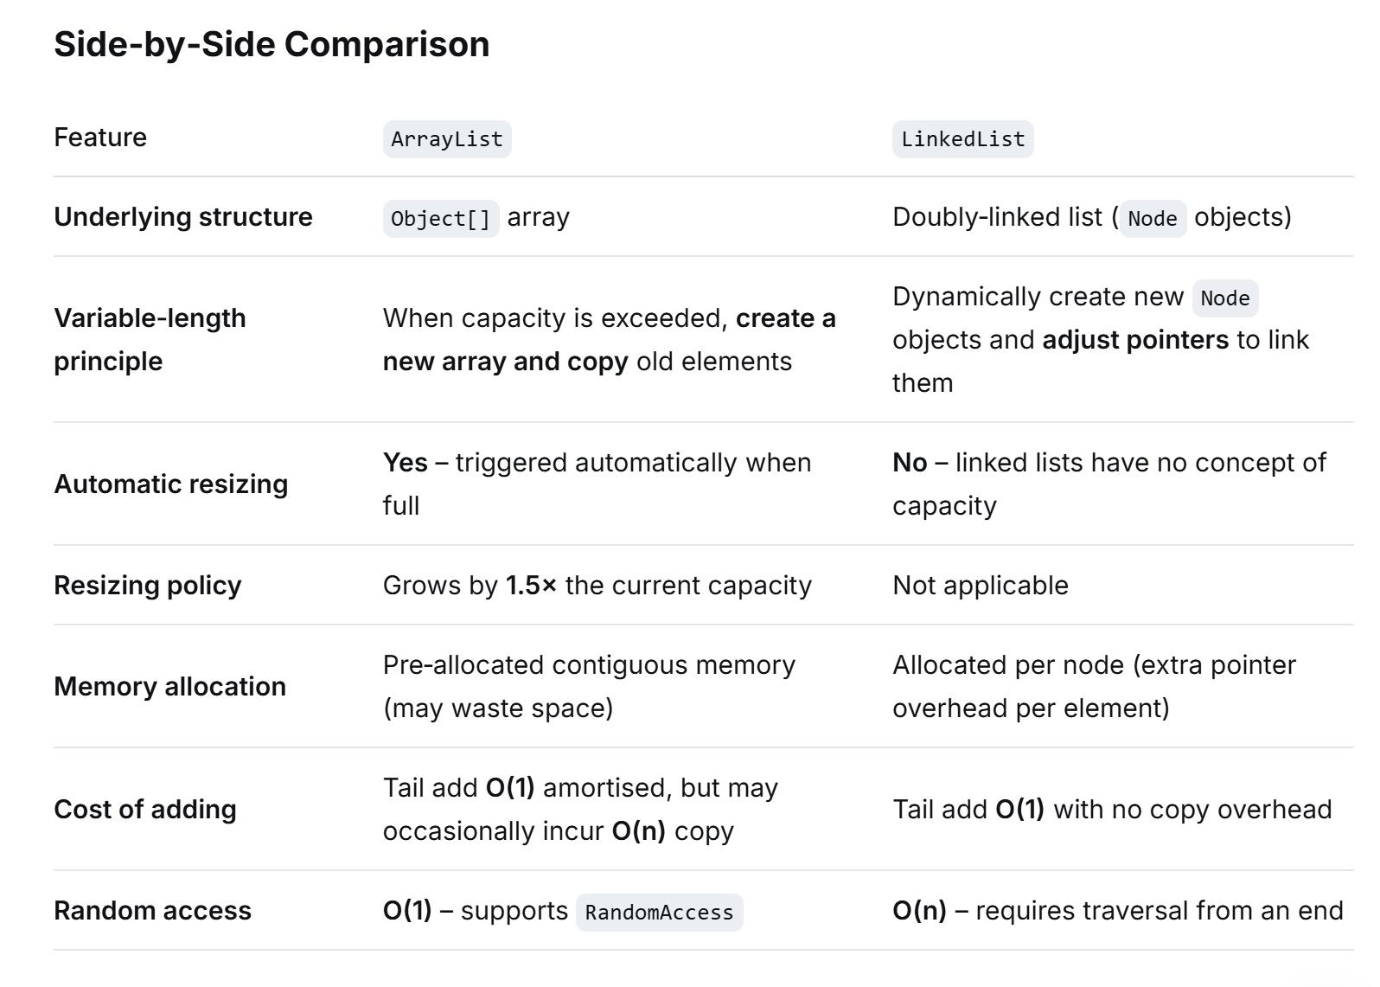

Generics in Depth
1. What Are Generics?
Generics are a mechanism in programming languages that allows us to define classes, interfaces, and methods using type parameters rather than fixed, concrete types. The actual types (such as Integer, String, or Customer) are specified when the code is actually used (instantiated or invoked).
In a single sentence: Generics make "type" itself a configurable parameter, enabling both code reusability and type safety.

2. Why Do We Need Generics? — The Pain Points Without Them
In the era before generics (e.g., Java 1.4 or earlier, or C before templates), we typically used Object (in Java) or void* (in C) to write generic code. However, this approach had serious issues:
- Type Unsafety: When you store an object as Object, you must cast it back when retrieving it. If the type is wrong, a ClassCastException occurs at runtime.
- Code Redundancy: You had to write nearly identical code for every type (e.g., IntList, StringList, CustomerList).
- Poor Readability: Excessive casting made code obscure and prevented the compiler from performing static type checks.
Generics solve these problems by moving runtime errors to compile time and eliminating explicit casts.

3. Basic Usage of Generics
3.1 Generic Class
java
public class Box<T> {
private T content;
public void set(T t) { this.content = t; }
public T get() { return content; }
}
Usage: Box<String> stringBox = new Box<>();
3.2 Generic Interface
java
public interface List<E> {
void add(E e);
E get(int index);
}
3.3 Generic Method
A method whose return type or parameters use type parameters, scoped only to that method:
java
public static <T> T getMiddle(T... a) {
return a[a.length / 2];
}
The compiler typically infers the type, but you can also specify it explicitly: ClassName.<String>getMiddle(...).
3.4 Multiple Type Parameters
You can declare multiple type parameters, such as Map<K, V>.

4. Naming Conventions for Type Parameters (Common)
- T — Type
- E — Element (commonly used in collections)
- K — Key
- V — Value
- N — Number
- S, U, V — Second, third, and fourth type parameters
These are conventions, not strict rules.

5. Core Concept: Type Erasure
This is a key feature of Java's implementation of generics (C# differs, as we will compare later).
- Java generics are compile-time only: After compilation, generic type information is erased and replaced with raw types, with implicit casts inserted automatically.
- For example, Box<String> becomes Box at runtime. All T are replaced with Object (if unbounded), and the compiler automatically inserts a cast to String for the get() result.
- Due to erasure, Java generics do not retain concrete type parameters at runtime (e.g., you cannot use instanceof Box<String>). This is a major limitation.
Consequences of Erasure:
- Primitive types cannot be used (e.g., you must use Integer instead of int).
- Cannot instantiate a type parameter (new T() is invalid).
- Cannot create generic arrays (e.g., new T[10] is invalid; use ArrayList instead).
- Static members cannot use class-level generic parameters (since statics belong to the class, while generics are specific to instances).

6. Wildcards and Bounds
When using generic types, sometimes we don't want to fix a specific type but want to represent "some unknown type." This is where the wildcard ? comes in.
6.1 Unbounded Wildcard ?
List<?> represents a list of an unknown element type. You can only read from it (returning Object) and cannot add to it (except null).
6.2 Upper-Bounded Wildcard ? extends T
This means the type must be T or a subclass of T. For example, List<? extends Number> can accept List<Integer>, List<Double>, etc.
Readable but not writable (you cannot add any element except null, because the specific subtype is unknown).
6.3 Lower-Bounded Wildcard ? super T
This means the type must be T or a superclass of T. For example, List<? super Integer> can accept List<Integer>, List<Number>, List<Object>.
Writable but not readable (when reading, you can only treat elements as Object).
The PECS Principle (Producer Extends, Consumer Super)
- If a collection is a producer (provides elements), use ? extends.
- If a collection is a consumer (consumes elements), use ? super.

7. Type Constraints (Bounds)
When declaring a type parameter, you can specify bounds to restrict it to a subclass of a certain class or an implementor of certain interfaces:
java
public class NumberBox<T extends Number & Comparable<T>> { ... }
Here, T must be a subclass of Number and implement Comparable. Multiple bounds are allowed (but at most one class, and any number of interfaces).

8. Comparison of Generics Across Languages
Language | Implementation Mechanism | Retains Generics at Runtime? | Supports Primitive Types?
Java | Type Erasure (raw types at runtime) | No | No (requires wrapper classes)
C# / .NET | True Generics (runtime reification) | Yes | Yes (List<int>)
C++ | Templates (compile-time code generation) | No (but each instantiation generates separate code) | Yes
Scala / Kotlin | Based on JVM erasure, with enhancements (e.g., inline reification) | Partial | Partial support
- C# generics retain type information at runtime, so List<int> and List<string> are distinct types. This offers better performance (no boxing) and more complete reflection support.
- C++ templates are expanded at compile time without enforcing type safety (though techniques like SFINAE exist), and error messages are often notoriously difficult to read.

9. Summary of Benefits
- Type Safety: Compile-time checks reduce ClassCastExceptions.
- Eliminates Explicit Casts: Code becomes cleaner and more readable.
- Code Reusability: One piece of code works for many types, avoiding duplication.
- Foundation of Collections Frameworks: Such as List<T>, Map<K,V>, etc.
- Better IDE Support: Improves code completion and refactoring capabilities.

10. Limitations of Generics (Java-specific)
- Primitive types cannot be used as type parameters (require wrapper classes).
- Cannot create generic arrays directly.
- Cannot instantiate type parameters (new T()).
- Cannot use generic parameters in static contexts.
- Due to erasure, you cannot overload methods based solely on generic parameters (e.g., void print(List<String>) and void print(List<Integer>) conflict).
- Cannot catch generic exceptions (e.g., catch T).
- Inheritance relationships: Box<String> is not a subtype of Box<Object>, but List<String> is a subtype of List<?>.

11. Real-World Application Scenarios
- Collections Framework: ArrayList, HashMap, HashSet.
- Utility Classes: e.g., Collections.sort() uses generics to ensure type-safe comparators.
- Building Generic Algorithms: Such as sorting, searching, and transformation functions.
- Dependency Injection Containers and ORM Frameworks (e.g., Hibernate's Session.get(Class<T>, id)).
- Functional Programming (Java 8's Function<T,R>, etc.).

12. Advanced Topic: Generics and Reflection
Although Java generics are erased, some generic signature information is retained in the class files (via signatures). You can access this information using reflection (e.g., via ParameterizedType). This is commonly used in framework development, such as generic DAO wrappers in MyBatis.

13. Best Practices in Development
- Prefer generic methods over wildcards where possible, as they are clearer.
- Follow the PECS principle when deciding between extends and super.
- Avoid raw types unless dealing with legacy code compatibility.
- Set reasonable bounds on generic parameters to increase safety.
- Do not overuse generics; excessively complex generics (nested wildcards) harm readability.

14. Sample Code Snippets (Java)
java
// Generic class
public class Pair<K, V> {
private K key;
private V value;
public Pair(K key, V value) { this.key = key; this.value = value; }
public K getKey() { return key; }
public V getValue() { return value; }
}

// Generic method + wildcard
public static double sumOfList(List<? extends Number> list) {
double sum = 0.0;
for (Number n : list) sum += n.doubleValue();
return sum;
}

// Usage
Pair<String, Integer> pair = new Pair<>("Age", 30);
List<Integer> ints = Arrays.asList(1,2,3);
System.out.println(sumOfList(ints)); // 6.0

15. Conclusion
Generics are an indispensable feature in modern statically-typed languages, striking a balance between type safety and code reusability. The key to mastering generics lies in understanding their declaration syntax, the type erasure mechanism (specifically for Java), wildcard usage, and the differences in implementation across languages. In real-world development, proper use of generics makes your code more robust and elegant.

Complete Guide to Set Implementations in Java: HashSet, LinkedHashSet, and TreeSet
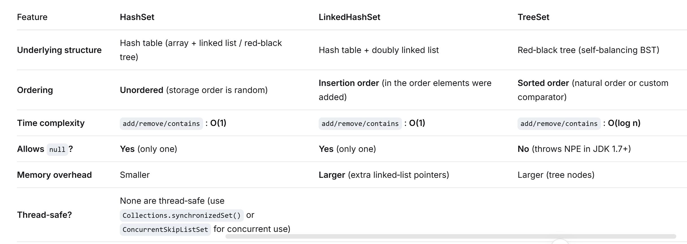
2. Detailed Explanation of Each Implementation
2.1 HashSet – Pure Hashing, Fastest
- Underlying principle : backed by a HashMap; elements are stored as keys of the map, with a dummy PRESENT object as the value.
- Resizing : initial capacity = 16, load factor = 0.75. When the size exceeds capacity * 0.75, the capacity doubles and all elements are re-hashed.
- Critical rule : you must override hashCode() and equals() correctly; otherwise duplicate detection breaks.
- Use case : when you only care about uniqueness and do not care about order – e.g. counting unique IPs, filtering duplicate IDs.
2.2 LinkedHashSet – Speed + Insertion Order
- Underlying principle : extends HashSet but uses a LinkedHashMap internally (via a package-private constructor). A doubly linked list runs through all entries to record insertion order.
- Performance : basic operations are still O(1), but iteration is slightly slower than HashSet (though often faster than HashSet when iterating because it traverses the linked list, not the entire bucket array).
- Use case : when you need to preserve the original insertion order – e.g. LRU cache prototypes, preserving parameter order in JSON, or generating fixed-order collections.
2.3 TreeSet – Sorted, Range-Query Powerhouse
- Underlying principle : backed by a NavigableMap (actually TreeMap), implemented as a red-black tree.
- Sorting :
  - Natural ordering – elements must implement Comparable.
  - Custom ordering – supply a Comparator at construction.
- Special APIs : supports range queries – first(), last(), headSet(to), tailSet(from), subSet(from, to), ceiling(), floor(), etc.
- null handling : not allowed because comparisons require compareTo() or compare(), which throw NullPointerException on null (unless a special comparator like Comparator.nullsFirst() is used, which is rare).
- Use case : when you need a dynamically sorted set – e.g. leaderboards (top 10 scores), time-stamped logs, price range queries (“find products between 100 and 200”).

3. Deep Dive – Hidden Constructor and Underlying Structures
3.1 The Package-Private Constructor in HashSet
LinkedHashSet actually calls a hidden constructor of HashSet:
java
// Hidden constructor in HashSet (used only by LinkedHashSet)
HashSet(int initialCapacity, float loadFactor, boolean dummy) {
map = new LinkedHashMap<>(initialCapacity, loadFactor);
}
That’s why LinkedHashSet has both the unique-checking ability of HashSet and the ordering of LinkedHashMap.
3.2 Internal Anatomy of HashSet – Array + Linked List / Red-Black Tree
- Table : Node<K,V>[] table – default length 16.
- Nodes : each node stores hash, key (your element), value (the dummy PRESENT), and a next pointer.
- Treeification :
  - When a bucket’s chain length ≥ 8 and the total table size ≥ 64, the chain is converted to a red-black tree (TreeNode).
  - If chain length ≥ 8 but table size < 64, the table resizes (because collisions are assumed to be due to small table size).
  - When tree nodes drop to ≤ 6, the tree is untreeified back to a linked list.
- Why threshold 8? Based on Poisson distribution: under a load factor of 0.75, the probability of 8 nodes in one bucket is ~0.00000006. Treeification is a safeguard against malicious hash collisions.
3.3 Internal Anatomy of LinkedHashSet – Array + Doubly Linked List
- Inherits the table structure of HashSet, but each node extends LinkedHashMap.Entry which adds before and after pointers.
- The global doubly linked list is independent of the bucket array – it connects all entries in insertion order (or access order, though LinkedHashSet disables access-order by default).
- Iteration : the iterator traverses this linked list, so iteration time is O(n) (independent of table capacity), making iteration often faster than HashSet (which scans the entire table including empty buckets).
3.4 Internal Anatomy of TreeSet – Red-Black Tree
- Each node (Entry) has left, right, parent pointers and a color (red/black).
- Tree height is strictly log₂(n), giving O(log n) for all operations.
- Uniqueness : determined only by Comparator.compare(a,b) == 0 or a.compareTo(b) == 0. Even if equals() returns false, if the comparator returns 0, the element is considered a duplicate and will replace the old one.
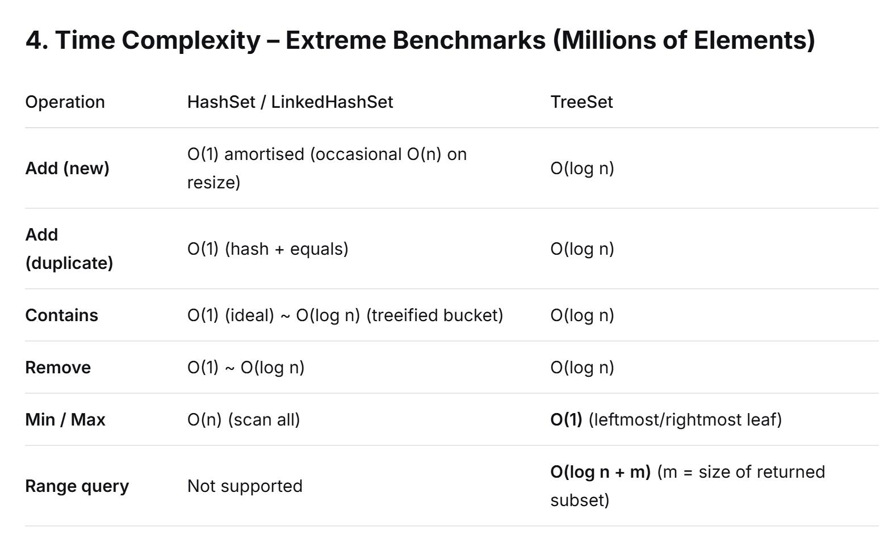
5. Memory Footprint – Breakdown (64-bit JVM, compressed oops)
- Empty HashSet : ~88 bytes (includes HashMap fields).
Per stored element (node) : ~32-40 bytes (hash, key ref, next ref, object header).
- LinkedHashSet : each element adds ~16 bytes (two extra pointers: before and after). For 1M strings, this adds ~16 MB extra.
- TreeSet : each node ~48-56 bytes (extra left/right/parent pointers and color flag). However, it does not reserve a 2× capacity array like HashMap, so for extremely large sets (tens of millions), TreeSet can actually consume less memory than HashSet when the latter’s load factor forces a large table.

6. Handling of null – Underlying Mechanisms
- HashSet / LinkedHashSet : allow one null because HashMap explicitly handles null keys (hash code = 0) and stores them in bucket 0. Only one null is allowed because a second would overwrite the first.
- TreeSet : never allows null by default – the first insertion triggers null.compareTo(null) or comparator.compare(null, null), which throws NullPointerException. Exception: if you pass a custom comparator that handles null (e.g. Comparator.nullsFirst()), then null can be stored.

7. Serialisation and Iterators – Subtle Details
- Fail-Fast : all three iterators are fail-fast – if the set is structurally modified (except via the iterator’s own remove()) during iteration, a ConcurrentModificationException is thrown.
- Serialisation : all implement Serializable. However, HashSet and LinkedHashSet do not serialise the bucket table – they only write the size and the elements. On deserialisation, they recompute hash distributions, which is portable across JVM environments.
- Spliterator :
  - HashSet / LinkedHashSet use HashMapSpliterator – does not split efficiently unless the set is huge.
  - TreeSet uses TreeMapSpliterator – can split by subtrees, so it performs better in parallel streams.

8. Edge Cases and Pitfalls – What to Avoid
❗ Pitfall 1: Forgetting hashCode() in custom objects
- Consequence : even if two objects are logically equal, their default hashCode() returns different values, so they are stored as distinct elements. Duplicate detection fails.
- Rule : always override hashCode() whenever you override equals(), and ensure consistency (equals true ⇒ hashCode equal).
❗ Pitfall 2: Comparator returns 0 while equals returns false in TreeSet
- Consequence : TreeSet treats them as the same element and overwrites the old one. If you rely on uniqueness but the objects are not truly equal, you lose data.
❗ Pitfall 3: Mutating objects already stored in a HashSet
- Consequence : if you change fields that contribute to hashCode(), the object’s new hash points to a different bucket, but it remains in the old bucket. Then contains() and remove() fail to find it, causing memory leaks.
- Best practice : use immutable objects (like String, Integer) in sets.
❗ Pitfall 4: LinkedHashSet and access-order
- By default, accessOrder = false (insertion order). If you ever set it to true (via reflection – not exposed in LinkedHashSet), get operations would reorder the linked list, which is typically used in LRU caches but would break the predictable iteration order of LinkedHashSet.
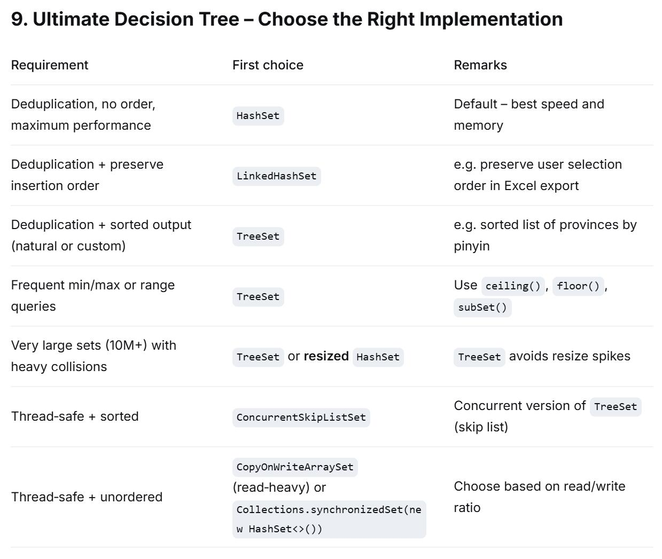
10. Sample Code – See the Ordering Difference
public class SetDemo {
public static void main(String[] args) {
List<Integer> input = IntStream.range(0, 20).boxed().collect(Collectors.toList());

Set<Integer> hashSet = new HashSet<>(input);
Set<Integer> linkedSet = new LinkedHashSet<>(input);
Set<Integer> treeSet = new TreeSet<>(input);

System.out.println("HashSet order (unordered, bucket‑dependent): " + hashSet);
// Output may look ordered for Integer because Integer.hashCode() == value and table size is large,
// but this is coincidental – do not rely on it.

System.out.println("LinkedHashSet order (insertion order): " + linkedSet); // always 0..19
System.out.println("TreeSet order (natural ascending): " + treeSet); // always 0..19
}
}

In-Depth Explanation of the Red-Black Tree
The Five Core Properties of a Red-Black Tree (The Golden Rules)
A Red-Black Tree maintains its balance through the following five rules. As long as these are strictly obeyed, the tree’s height stays effectively bounded:
- Each node is either red or black (a boolean flag).
- The root node is always black.
- All leaves (NIL null nodes) are black – Note: in Java’s TreeMap, null represents NIL and is logically treated as black.
- Both children of a red node must be black – i.e., no two consecutive red nodes are allowed on any path.
- Every path from any given node to its descendant leaf nodes (NIL) contains exactly the same number of black nodes – this is the most critical constraint, known as perfect black-height balance.
Intuition: Rule #5 guarantees that if one path has a certain number of black nodes, all other paths must have the exact same count. This forcibly prevents the tree from becoming severely skewed.

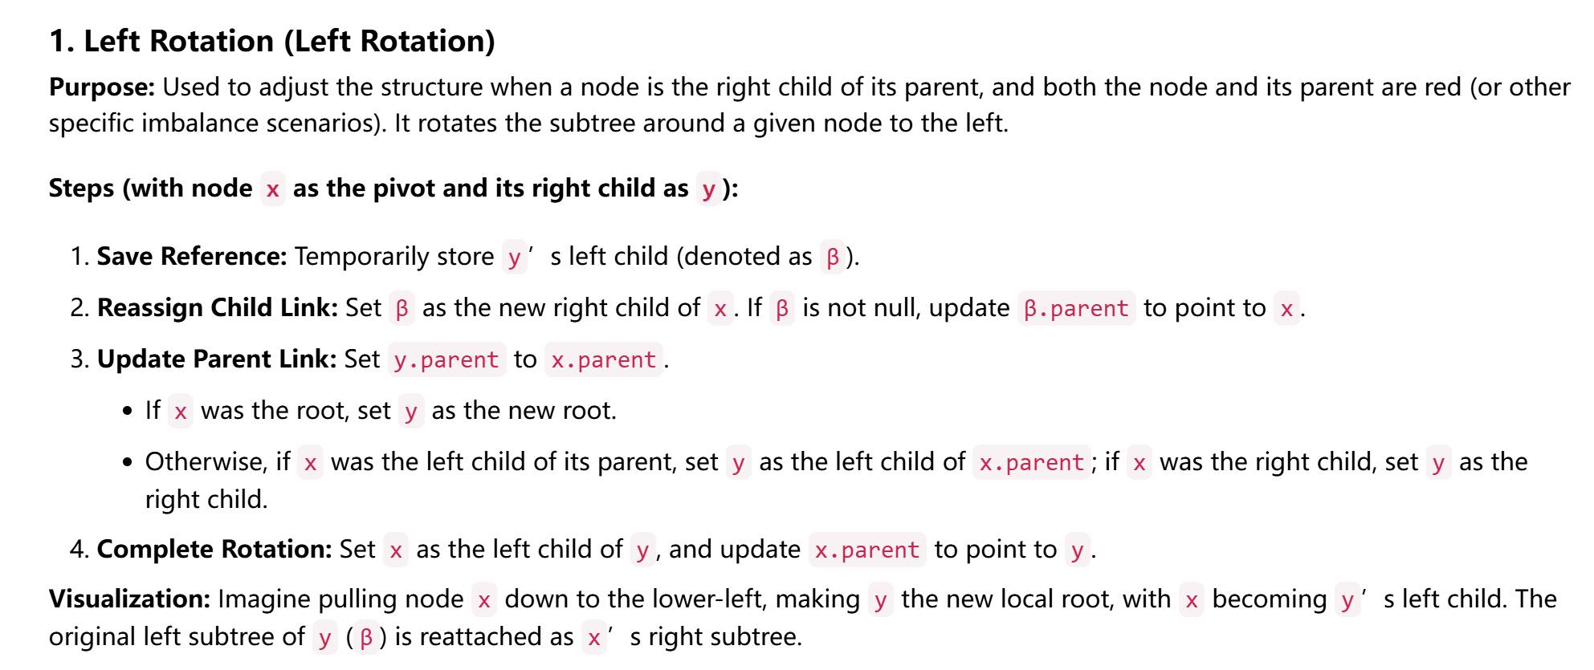
def left_rotate(root, x):
y = x.right # Step 1: y is x's right child
x.right = y.left # Step 2: Reattach y's left child (β) as x's right child
if y.left is not None:
y.left.parent = x

y.parent = x.parent # Step 3: Update y's parent
if x.parent is None:
root = y # x was root, so y becomes new root
elif x == x.parent.left:
x.parent.left = y
else:
x.parent.right = y

y.left = x # Step 4: Set x as y's left child
x.parent = y
return root

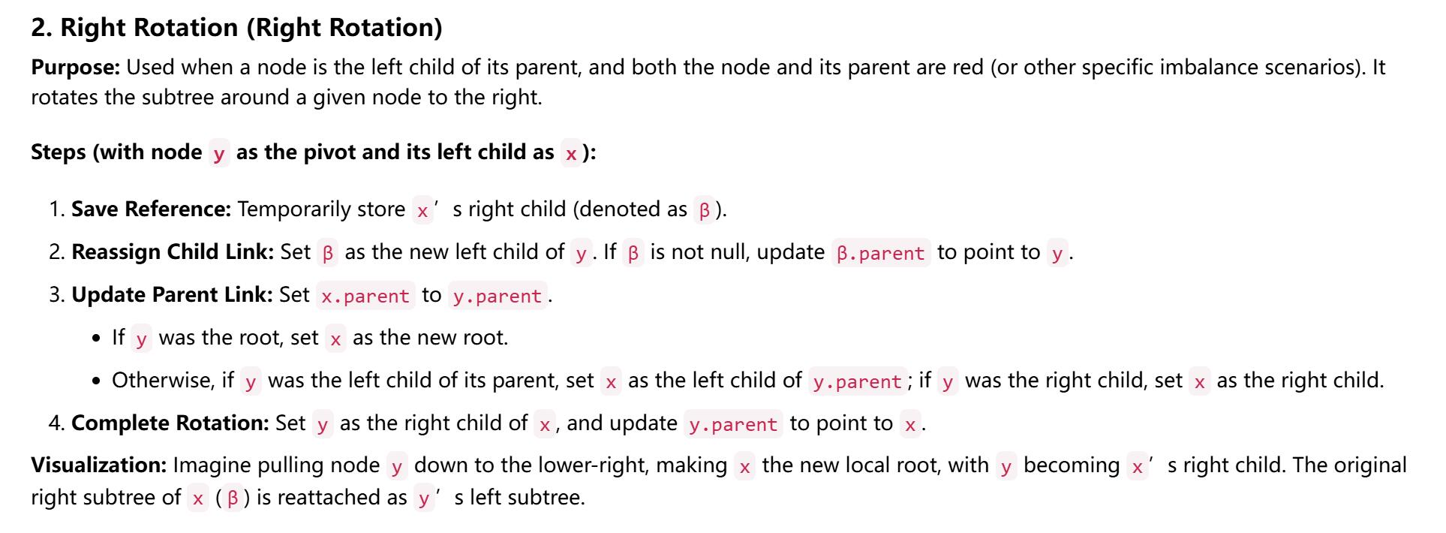
def right_rotate(root, y):
x = y.left # Step 1: x is y's left child
y.left = x.right # Step 2: Reattach x's right child (β) as y's left child
if x.right is not None:
x.right.parent = y

x.parent = y.parent # Step 3: Update x's parent
if y.parent is None:
root = x # y was root, so x becomes new root
elif y == y.parent.left:
y.parent.left = x
else:
y.parent.right = x

x.right = y # Step 4: Set y as x's right child
y.parent = x
return root

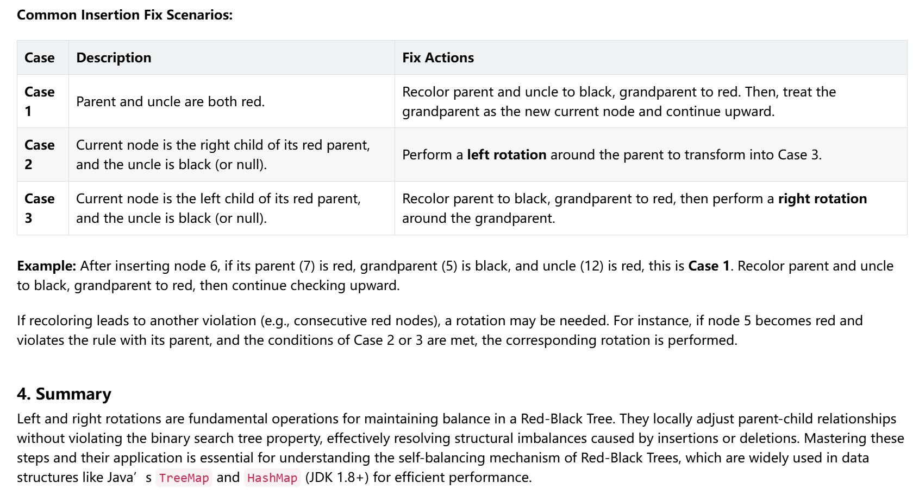

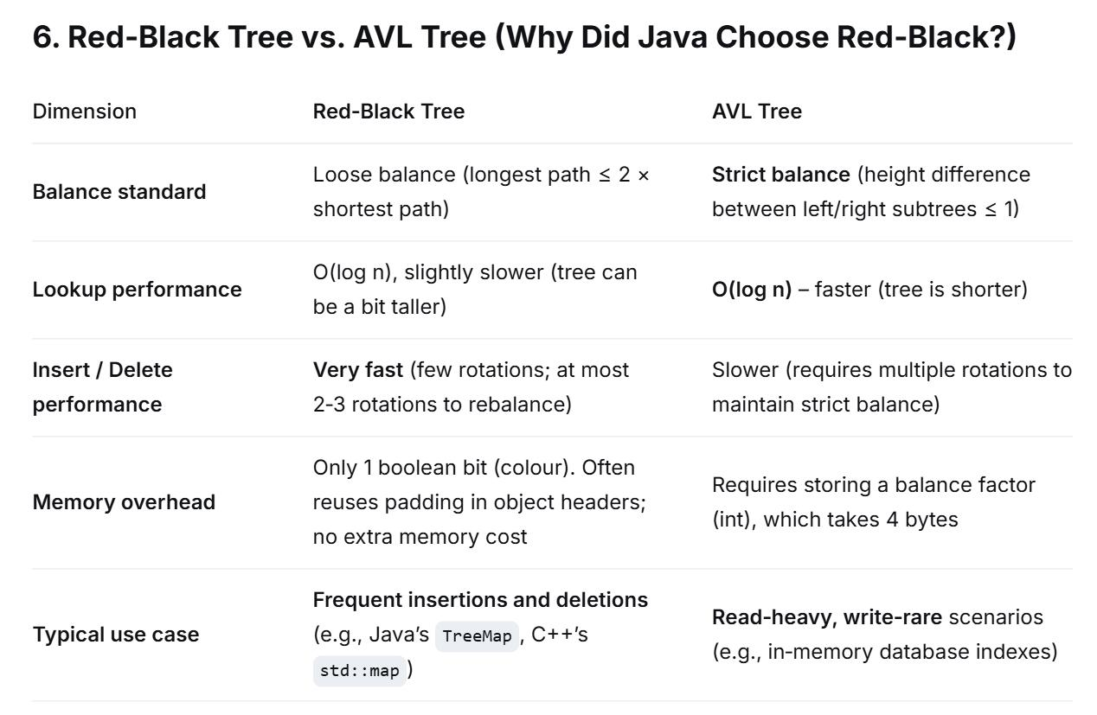

2026/7/17
Let’s understand HashSet by telling a story.
Imagine you are a super librarian in charge of a row of numbered lockers (say, 0 to 15). Under the hood, a HashSet is exactly such an array of lockers (more precisely, it uses a HashMap’s internal array).
Step 1: Adding an element – what really happens?
When you call set.add("apple"), the computer (the librarian) does these things, step by step:
- Compute a “fingerprint” – The librarian takes the object “apple” and uses a small machine (the hashCode() method) to generate a number, say 1234567. Note: this number is huge and doesn’t directly map to locker numbers 0~15.
- Turn it into a “locker number” – The librarian uses a mixing algorithm (the “perturbation function”) that mixes the high and low bits of that big number, then takes the remainder when divided by the total number of lockers (in reality, it uses (n - 1) & hash). The result is a specific locker number, for example locker #3.
  - Why mix the bits? Because if “apple” and “pineapple” happen to have big numbers that differ only in the high bits but are identical in the low bits, without mixing they would end up in the same locker. Mixing helps spread them evenly to avoid congestion.
- Check locker #3:
  - Case A (locker is empty) – Just put “apple” in. Done! It takes only 1 unit of time (O(1)).
  - Case B (locker already has something, e.g., a “banana”) – This is called a hash collision. The librarian doesn’t throw away “apple”. Instead, they tie a rope (linked list) behind “banana” and hang “apple” at the end of that rope.

Step 2: What about collisions? The “shape-shifting” of linked lists and red-black trees
If locker #3 becomes very popular and a long rope (say, 8 items) is hanging there, finding “apple” becomes slower because you have to count from the first item one by one (traverse the list). In the worst case you’d have to check 8 times (O(n)).
Java has a clever “shape-shifting” mechanism (since JDK 8):
- If the rope on any locker grows longer than 8, and the total number of lockers exceeds 64, the librarian thinks: “This rope is too long and annoying – it takes too long to search.”
- So they reorganise that rope into a small “tree” (a red-black tree). In a tree, you only need to jump 2~3 steps to find an item (O(log n)), which is much faster than counting 8 items.
- If later many items are removed and the tree shrinks below 6 nodes, they turn it back into a rope (linked list) to avoid the overhead of maintaining a tree.

Step 3: What if the lockers are full? Resizing – the big move
You start with only 16 lockers. You can’t wait until all 16 are crammed full, because by then the last few lockers would be terribly crowded.
- The rule (load factor = 0.75): The librarian decides: as soon as the total number of items > number of lockers × 0.75 (i.e., 16 × 0.75 = 12 items), we must enlarge the locker room immediately.
- How to enlarge? Simply double the number of lockers – from 16 to 32.
- Key point (rehashing): Enlarging is not as simple as moving everything from locker #3 to the new locker #3. Because locker number = hash % total_lockers. When total changes from 16 to 32, the remainder changes!
  - For example, “apple” was in locker #3 before, but after resizing it might be recalculated to locker #19.
  - So during resizing, the librarian must take every item out of every old locker, recalculate its new locker number, and put it into the new lockers. That’s why resizing is costly – if you know you’ll store 10,000 items, it’s much better to create the HashSet with a large initial capacity to avoid multiple expensive moves.

Step 4: How to decide if an item is a duplicate? Two methods are both essential!
This is a very common pitfall for beginners. When you store custom objects (like a Person class), determining duplicates requires both methods:
- Which locker to go to? Depends on hashCode().
- Once at the locker, are they really the same person? Depends on equals() – compare name, ID, etc.
A classic mistake: You override equals() (e.g., two people with the same name are considered equal), but you forget to override hashCode().
- When you store Person("Alice"), Java uses the default hashCode() based on memory address, and let’s say it ends up in locker #5.
- When you store another Person("Alice"), because the memory address is different, the default hash gives a different value, say locker #10.
- As a result, the two “Alice” objects go to different lockers – #5 and #10. The HashSet thinks they are not duplicates, and your deduplication fails!
Golden rule: Whenever you override equals(), you must override hashCode() so that if equals() returns true, their hashCode() must be equal.

Step 5: The deadly “lost object” problem – never change an object after you put it in!
Suppose you store a Person object with id = 1 (and id participates in hashCode() calculation).
- When stored, it is placed in locker #3.
- After storing, you change that person’s id to 2.
- Now the object’s hash value has changed, but physically it still sits in locker #3.
- When you try set.remove(thatObject), the librarian computes the new hash value and goes to locker #5 to find it. Locker #5 is empty, so the removal fails.
- The object becomes a “ghost” – permanently stuck in locker #3, neither removable nor findable.
Lesson: If you are going to store an object in a HashSet, the key fields (those used in hash calculation) should be immutable (final) – or at least you must never modify them after insertion.

Step 6: Why does the iteration order look so “random”?
You add “apple”, “banana”, “grape” in that order.
But when you print them, you might see “grape”, “apple”, “banana”.
- That’s because they are stored based on the remainder of their hash values.
- When iterating, the librarian goes through lockers in order: locker #0, #1, #2, … and picks out whatever is there.
- So the output order depends entirely on the hash-remainder results, not on the order you added them.

Question | Plain answer
What is the underlying structure? | An array + linked lists + red-black trees combined together.
How fast is adding an element? | Normally blazing fast (O(1)) because we directly calculate the locker number.
When does it slow down? | When collisions are severe and we have to traverse a long list.  Java rescues with red-black trees (O(log n)).
Why override hashCode()? | To tell the librarian that two logically equal objects must go  to the same locker – otherwise deduplication breaks.
Why override equals()? | To tell the librarian, once they’re in the same locker,  how to confirm that they are truly identical.
What initial capacity should I set? | If you know you’ll store 1000 items, do new HashSet<>(1500) to avoid  repeated resizing – performance doubles.
Is it thread-safe? | No! If multiple threads modify it concurrently, data corruption can occur.  For shared use, use ConcurrentHashMap.newKeySet().

Let’s focus purely on the perturbation function – what it is, why it exists, and how it works –

The Setup: The "Big Fingerprint" Problem
Remember our librarian and the row of lockers (say, 0 to 15)?
When you put an object into a HashSet, the computer first calls hashCode() on that object. This returns a 32-bit integer – a number that can be as large as 2,147,483,647. That’s a huge, huge number.
But our locker room only has, say, 16 lockers. So the computer cannot use that giant number directly. It has to shrink it down to a locker number between 0 and 15.
To do this, Java uses a bitwise trick: (n - 1) & hash (where n is the number of lockers, which is always a power of 2).
For n = 16, (16 - 1) = 15, which in binary is 1111 (only the lowest 4 bits are 1).
This operation only looks at the lowest 4 bits of the giant hash code. All the higher bits – the rest of that huge number – are completely ignored.

The Crisis: Two Different Objects, Same Locker
Imagine these two objects:
- Object A has a hash code: 0x1234 5678 (in hexadecimal).
- Object B has a hash code: 0xABCD 5678.
If you only look at the lowest 4 bits (the last hex digit, which is 8 for both), they are identical!
Even though their upper parts (1234 vs ABCD) are totally different, Java will send both to the same locker (#8) because the low bits are the same.
This causes a hash collision. And if you have many such objects that only differ in their high bits, they will all pile up in the same locker, creating a long, slow-to-search linked list.
The computer thinks: "I'm wasting all this rich, random information in the high bits. I need to mix the high bits into the low bits before I throw them away!"

The Solution: The Perturbation Function (The "Mixer")
This is exactly what the perturbation function does. It’s a tiny piece of code inside HashMap (and used by HashSet):
java
static final int hash(Object key) {
int h;
return (key == null) ? 0 : (h = key.hashCode()) ^ (h >>> 16);
}
Let's break it down:
- h = key.hashCode() – Get the original 32-bit hash code.
- h >>> 16 – Shift all the bits 16 places to the right. The left side gets filled with zeros.
This takes the upper 16 bits (the high part) and moves them down to where the lower 16 bits used to be.
- h ^ (h >>> 16) – Perform an XOR (exclusive OR) between the original hash h and this shifted version.
This simple operation mixes the high-half and the low-half of the hash code together.

A Concrete Example (in simple numbers)
Let’s say a hash code is 32 bits (imagine it's 0x1234 5678):
- Original h: 0x1234 5678
- h >>> 16: Shift right by 16 bits → 0x0000 1234 (the top half moved to the bottom)
- XOR them:
text
0x1234 5678
^ 0x0000 1234
--------------
0x1234 444C
Now, the low 4 bits are C (which is 1100 in binary). If we only used the original hash, the low bits were 8 (1000).
By mixing, the high part (0x1234) has influenced the final low bits.
Now, if two objects have the same low bits but different high bits, after perturbation, their final low bits will likely become different – reducing collisions!

Why Exactly 16 Bits? Why XOR?
- 16 bits is exactly half of a 32-bit integer. It’s a perfect split. It ensures that every single bit in the original hash has a chance to affect the lower bits, because the upper half is moved down and mixed.
- XOR (^) is used instead of AND or OR because XOR gives a perfect 50/50 distribution of bits.
If you use AND or OR, certain bit patterns can bias the result (e.g., AND tends to produce more zeros). XOR ensures the randomness from the original hash is preserved as much as possible.

The Golden Rule: Balance Between Speed and Quality
You might ask: "Why not mix the bits 10 times to make it super random?"
Because performance matters!
- Doing one right-shift and one XOR takes almost zero time (just a few CPU cycles). Adding an element to a HashSet should be ultra-fast (O(1)).
- If you mixed too many times, you would slow down every add and get operation for every single object, just to handle a few edge cases.
The Java designers found that one shift + one XOR is the perfect sweet spot:
It spreads the high-bit influence to the low bits just enough to make collisions significantly less likely, without sacrificing speed.

A Fun Fact: JDK Evolution
- In JDK 7 and earlier, the perturbation function was more complex – it used 4 shifts and 5 XOR operations!
Why? Because back then, if collisions happened, you were stuck with a slow linked list. So they tried extra hard to avoid collisions.
- In JDK 8 and later, they simplified it to just 1 shift and 1 XOR.
Why? Because they introduced the red-black tree improvement (the "shape-shifting" we talked about earlier).
Even if collisions still happen, the tree can handle them efficiently (O(log n)). So they could reduce the perturbation cost and make everyday operations faster!

LinkedHashSet
Part 1: The Structure – Lockers + a "Fancy Notebook"
Remember our librarian and the row of numbered lockers? With LinkedHashSet, the librarian gets an upgrade.
While HashSet only has the lockers (the hash table), LinkedHashSet adds a notebook (doubly linked list) that keeps track of the order in which items were added.
But here's the key: LinkedHashSet doesn't implement this itself. It inherits from HashSet and tells its parent to use a special map called LinkedHashMap instead of the regular HashMap.
Let's look at the source code:
java
// HashSet has a special constructor (package-private)
HashSet(int initialCapacity, float loadFactor, boolean dummy) {
map = new LinkedHashMap<>(initialCapacity, loadFactor);
}

// LinkedHashSet calls this special constructor
public LinkedHashSet() {
super(16, .75f, true); // the 'true' is the secret signal
}
Translation: The LinkedHashSet administrator doesn't use the regular HashMap assistant. Instead, he hires a LinkedHashMap assistant, who comes with a built-in notebook.

Part 2: What's Inside LinkedHashMap?
If you open LinkedHashMap.java, you'll see that its nodes (entries) are special:
java
// Regular HashMap node – only has 'next' for handling collisions
static class Node<K,V> {
final int hash;
final K key;
V value;
Node<K,V> next; // points to the next item in the same locker
}

// LinkedHashMap node – inherits from HashMap.Node and adds two more pointers!
static class Entry<K,V> extends HashMap.Node<K,V> {
Entry<K,V> before, after; // points to previous and next in the notebook
}
Additionally, LinkedHashMap has three important member variables:
java
// The first page of the notebook (oldest item)
transient LinkedHashMap.Entry<K,V> head;
// The last page of the notebook (newest item)
transient LinkedHashMap.Entry<K,V> tail;
// Ordering mode: false = insertion order (default), true = access order
final boolean accessOrder;
Story time:
The librarian now has two tools:
- A row of lockers (hash table) – for ultra-fast storage and retrieval.
- A fancy notebook (doubly linked list) – where every page has:
  - The item's name.
  - A note saying "previous page is ___"
  - A note saying "next page is ___"
The notebook's first page (head) is the oldest item, and the last page (tail) is the newest item.

Part 3: Two Notebook Ordering Modes
LinkedHashMap has a constructor parameter called accessOrder:
java
public LinkedHashMap(int initialCapacity, float loadFactor, boolean accessOrder) {
super(initialCapacity, loadFactor);
this.accessOrder = accessOrder;
}
Mode 1: Insertion Order (accessOrder = false) – Used by LinkedHashSet
- Rule: Every time you add a new item (a Key that didn't exist before), the librarian appends that page to the end (tail) of the notebook.
- Iteration: When you go through the notebook from head to tail, you see items in the exact order they were added.
- Use case: LinkedHashSet, display lists that need to preserve insertion order.
Mode 2: Access Order (accessOrder = true) – The Secret Sauce for LRU!
- Rule: Every time you touch (get or put) a Key, whether it's new or old, the librarian tears that page out and pastes it at the end (tail) of the notebook.
- Result:
  - The head is always the item that hasn't been touched for the longest time (Least Recently Used).
  - The tail is always the item that was just touched (Most Recently Used).

Part 4: Deep Dive – How Does Access Order Work?
When accessOrder = true, every get() or put() on an existing Key triggers the afterNodeAccess(Node<K,V> e) method.
Here's the source code (JDK 8), with comments:
java
void afterNodeAccess(Node<K,V> e) { // move node e to the tail of the list
LinkedHashMap.Entry<K,V> last;
// Only if accessOrder is true and e is not already the tail
if (accessOrder && (last = tail) != e) {
LinkedHashMap.Entry<K,V> p = (LinkedHashMap.Entry<K,V>)e,
b = p.before, a = p.after;
// Step 1: Remove p from its current position
p.after = null;
if (b == null) // if p was the head, head now points to its next
head = a;
else
b.after = a; // otherwise, skip over p

if (a != null) // if p had a next, update its before pointer
a.before = b;
else
last = b; // if p was the tail (won't happen here)

// Step 2: Paste p at the tail
if (last == null) // if list was empty (won't happen)
head = p;
else {
p.before = last;
last.after = p;
}
tail = p; // update tail to p
++modCount;
}
}
Story translation:
Someone asks the librarian for "Apple". The librarian thinks: "Since you just asked for it, it must be popular!" So he:
- Tears the "Apple" page out of its current spot (fixing the before/after pointers of its neighbors).
- Pastes "Apple" at the very end of the notebook (after the current tail).
- Updates the notebook's cover to say the last page is now "Apple".

Part 5: The Ultimate Feature – removeEldestEntry (Auto-Eviction)
Having access order is great, but the real power of an LRU cache is automatically deleting the oldest item when the cache is full.
LinkedHashMap provides a hook method:
java
protected boolean removeEldestEntry(Map.Entry<K,V> eldest) {
return false; // default: never delete anything
}
This method is called after every new insertion (in afterNodeInsertion). We just override it to return true when our cache size exceeds a limit, and the map will automatically delete the head (oldest page)!
afterNodeInsertion source code:
java
void afterNodeInsertion(boolean evict) { // evict means "allow deletion"
LinkedHashMap.Entry<K,V> first;
// If deletion is allowed, head exists, and removeEldestEntry says true
if (evict && (first = head) != null && removeEldestEntry(first)) {
K key = first.key;
removeNode(hash(key), key, null, false, true); // delete the head!
}
}
Perfect cycle:
- accessOrder = true ensures head is always the least recently used item.
- Overriding removeEldestEntry to return size() > maxCapacity ensures automatic eviction when the cache gets too big.

Part 6: Build an Industrial-Grade LRU Cache (Full Code)
Here's a complete, thread-safe LRU cache using LinkedHashMap (wrapped with synchronized):
java
import java.util.LinkedHashMap;
import java.util.Map;

/**
* LRU Cache implemented with LinkedHashMap
* @param <K> Key type
* @param <V> Value type
*/
public class LRUCache<K, V> {

private final int maxCapacity;
private final LinkedHashMap<K, V> map;

public LRUCache(int maxCapacity) {
this.maxCapacity = maxCapacity;
// Key: third parameter 'true' enables access order
this.map = new LinkedHashMap<K, V>(16, 0.75f, true) {
@Override
protected boolean removeEldestEntry(Map.Entry<K, V> eldest) {
// Delete the oldest when size exceeds max capacity
return size() > maxCapacity;
}
};
}

// Store data
public synchronized V put(K key, V value) {
return map.put(key, value);
}

// Retrieve data (triggers afterNodeAccess, moving it to the tail)
public synchronized V get(Object key) {
return map.get(key);
}

// Check if key exists
public synchronized boolean containsKey(Object key) {
return map.containsKey(key);
}

// Get current cache size
public synchronized int size() {
return map.size();
}

// Print cache contents (for debugging)
public synchronized void printCache() {
// LinkedHashMap's iterator follows the doubly linked list order
for (Map.Entry<K, V> entry : map.entrySet()) {
System.out.print(entry.getKey() + ":" + entry.getValue() + " ");
}
System.out.println();
}

// Test code
public static void main(String[] args) {
LRUCache<String, Integer> cache = new LRUCache<>(3);

cache.put("A", 1);
cache.put("B", 2);
cache.put("C", 3);
cache.printCache(); // Output: A:1 B:2 C:3 (insertion order)

// Access A, making it the most recently used
cache.get("A");
cache.printCache(); // Output: B:2 C:3 A:1 (A moves to the end)

// Insert D – cache size is 3, oldest is B, so B gets evicted
cache.put("D", 4);
cache.printCache(); // Output: C:3 A:1 D:4 (B is gone)
}
}
Output Analysis:
- Insert A, B, C → notebook order: head -> A -> B -> C <- tail
- get("A") triggers access order → A moves to tail: head -> B -> C -> A <- tail
- Insert D → size becomes 4 > maxCapacity(3) → removeEldestEntry returns true → deletes head (which is B)
- Final cache: C, A, D (D at tail because it's the newest)

Part 7: Why Is This "Industrial-Grade"? Performance & Memory
Feature | LinkedHashMap-Based LRU
Time Complexity | get/put/remove are all O(1). Hash table gives O(1), plus pointer manipulation O(1).
Space Overhead | Each node stores two extra references (before/after), about 16 extra bytes per entry on 64-bit JVM.
Thread Safety | Not thread-safe. Our example uses synchronized for simple concurrency. For high concurrency, use ConcurrentLinkedHashMap or custom read-write locks.
Eviction Policy | LRU (Least Recently Used) – great for cache hit ratio in real-world applications.
Flexibility | Change accessOrder to false and you get FIFO (First-In-First-Out) eviction instead.

Part 8: Interview Question – When Is removeEldestEntry Called?
Many interviewers ask: Is removeEldestEntry called before or after insertion?
Answer: After insertion (inside afterNodeInsertion).
Sequence of events:
- Call map.put(key, value).
- Internally putVal inserts the new node, size++.
- Call afterNodeInsertion(evict).
- afterNodeInsertion checks removeEldestEntry(first) – if true, calls removeNode to delete the head.
So technically, the cache briefly has maxCapacity + 1 items (for microseconds) before the eviction happens.

Part 9: Complete Comparison Table – HashSet vs LinkedHashSet vs TreeSet vs LRU Cache
Feature | HashSet | LinkedHashSet | TreeSet | LRU Cache (LinkedHashMap)
Underlying Structure | HashMap | LinkedHashMap | TreeMap (Red-Black Tree) | LinkedHashMap + overridden eviction
Order | Unordered | Insertion order | Natural order / Comparator order | Access order (LRU)
Time Complexity | O(1) | O(1) | O(log n) | O(1)
Memory Overhead | Low | Medium (two extra pointers) | Medium (large tree nodes) | Medium (same as LinkedHashMap)
Eviction Mechanism | None | None | None | Automatic (deletes head)
Use Case | Ultra-fast dedup | Ordered dedup (display lists) | Sorted dedup (range queries) | Caching (prevent OOM)

Part 10: Pitfalls to Avoid (Important!)
Pitfall 1: LinkedHashSet Can't Directly Implement LRU
Set has only Keys, no Values, and lacks a get() method (only contains()). While contains() does trigger afterNodeAccess internally, Set isn't designed for cache eviction. Always use LinkedHashMap for caching.
Pitfall 2: Overriding removeEldestEntry – Use size() Carefully
In the override, just use size() directly – it works fine. Just don't do anything weird like calling this.size() from a subclass that overrides size() (which would be a bad design anyway).
Pitfall 3: Mutable Keys Don't Trigger Reordering
Only get() and put() trigger the access order reordering. If you modify a Key object's internal fields without calling put(), its position in the doubly linked list won't change. This is the same "ghost object" problem we saw with HashSet.
Pitfall 4: accessOrder Only Works on Existing Keys
- get() on an existing Key → reorders to tail.
- put() on an existing Key → reorders to tail.
- put() on a new Key → appends to tail (no need to reorder).
- containsKey() also triggers reordering (because it calls get() internally) – but only if accessOrder = true.

Final Summary (One Sentence to Remember)
LinkedHashSet is HashSet plus a doubly linked list that preserves insertion order. By changing that list's ordering to "access order" and overriding removeEldestEntry, you can build a high-performance LRU cache in just a few lines of code.

